# A Major Project Proposal on

# **Online Tour Guide System**

Submitted in Partial Fulfillment of the Requirements for

the Degree of **Bachelor of Engineering in** **Information Technology**

under Pokhara University

Submitted by:

**Dhan Bdr. Ghale, 13490**

**Kishor Kc Khattri, 13441**

**Mahesh Acharya, 13440**

**Ram Bdr. Khattri, 13442**

Date:

08-25-2017

 **Department of Information Technology Engineering**

**NEPAL COLLEGE OF**

**INFORMATION TECHNOLOGY**

Balkumari, Lalitpur, Nepal

***­­­­­­***

Contents

LIST OF FIGURES II

ABSTRACT III

KEYWORDS III

1. INTRODUCTION 1

1.1 BACKGROUND 1

1.2 PROBLEM STATEMENT 1

1.3 PROJECT OBJECTIVE 1

1.4 PROJECT SCOPE 2

1.5 SIGNIFICANCE OF STUDY 2

2. LITERATURE REVIEW 2

2.1 REVIEW 2

2.2 EXISTING SYSTEM 3

There are many tour guide system available for tourism of Nepal like Tour Guide in Nepal, Welcome Nepal, Discover Nepal etc. These all are online web applications providing information to tourist. 3

2.3 COMPARISON WITH THE EXISTING SYSTEM 3

3. PROPOSED METHODOLOGY: 3

3.1 SOFTWARE DEVELOPMENT PROCESS: 3

3.2 PROJECT DELIVERABLES 5

4. PROJECT TASK AND SCHEDULE 6

4.1 TASK AND TIME SCHEDULE 6

REFERENCES 7

# LIST OF FIGURES

Figure 1: Incremental Model 4

Figure 2: Gantt Chart 6

# ABSTRACT

*Online Tour Guide System is a web application that aims to help tourist to find best place to visit on basis of their time and budget. This system will help tourist to find nearest similar places on basis of their location. Tourist can also check hotel and related things around that place.*

*The system provides a platform that will act as a bridge between the tourist and tourism of Nepal. System will have a panel for a local tourism to introduce their business such as hotel and tour agencies etc. This system will provide these all facilities in single platform which will help tourist to choose best and reasonable place as they required.*

# KEYWORDS

*online tour guide system, tourist helper, tour in Nepal, tourism, place to visit*

# INTRODUCTION

## 1.1 BACKGROUND

Tour Guide system is very important for development of tourism in a country like Nepal. Tour guide system is a system that provide tourist to visit best and right place. Tourist can check all the places and can choose place for themselves as their financial range and time they have. All the tourist need guide to visit new place and travel around there so they need to hire guide, but this tour guide system may help them to go and travel without local guide. All the guide and tourist may not know new places to visit but this system will help them to know and visit new places.

## 1.2 PROBLEM STATEMENT

There are many tour guide system available for tourism of Nepal like Tour Guide in Nepal, Welcome Nepal, Discover Nepal etc. These all are online web applications providing information to tourist. Many local tourist and international tourist are taking advantages from these applications. Helping tourist to find people and services as they need.

Tour Guide systems available now does not have good search optimization for tourist. They are not able to providing similar nearest places for the tourist that they can travel there. These systems do not show tourism things around that place like hotel and other tourist agencies and tourist shop etc. Due to this tourist may feel difficult to find the things they need. Most of web available are not well responsive or not device friendly.

## 1.3 PROJECT OBJECTIVE

* To provide a platform for tourist to choose best place according to their budget and time.
* To find nearest similar places based on their location.
* To make easy to travel, to search place and things.
* To know about the places and hotels by reviews, and rating them as their satisfaction.

## 1.4 PROJECT SCOPE

Objective of our Online Tour Guide System can be listed as:

* Search best place according to their time and budget.
* Find nearest similar places to see according to their location.
* Find other facilities around the place they have chosen.
* To rating the place and reviews for tourist.
* A platform for local tourism to introduce their business and services.

## 1.5 SIGNIFICANCE OF STUDY

Online Tour Guide System is system that provide help for the tourist. This system will give information about the places and thing they need for travel. This web application will help tourist to get more information about the place where they want to travel. This system will provide them similar nearest places about which they may be unknown. Tourist will see and find other things they need for that place. After visiting the place and taking services tourist can review it and can see others reviews also. This system will have a place to put local tourism or business and services that related to tourism of that place.

# LITERATURE REVIEW

## 2.1 REVIEW

After a thorough research, we realized that there have been many attempts made in developing the system for managing the impatient billing, most of the existing system lacks flexibility, as it’s been years the systems were built, and the then tools and technologies used is in dire need to be updated as per the current practices.

Many local tourist and international tourist are taking advantages from these applications. Helping tourist to find people and services as they need. Tour Guide systems available now does not have good search optimization for tourist. They are not able to providing similar nearest places for the tourist that they can travel there. These systems do not show tourism things around that place like hotel and other tourist agencies and tourist shop etc.

## 2.2 EXISTING SYSTEM

We study the existing system that has been used for helping tourist.

## There are many tour guide system available for tourism of Nepal like Tour Guide in Nepal, Welcome Nepal, Discover Nepal etc. These all are online web applications providing information to tourist.

## 2.3 COMPARISON WITH THE EXISTING SYSTEM

Our system has numerous advantage over the traditional tour guide system. Our system facilitates the tourist and provide them with all the facilities to complete their tour successfully. Tourist can find nearest similar places based on chosen location. This system will have platform to introduce the local tourism like hotel and other tour agencies, shop, services that related to tourism. Over all this system will help to develop the tourism of Nepal and to introduce the Nepal and its beauty around the world.

# PROPOSED METHODOLOGY:

## 3.1 SOFTWARE DEVELOPMENT PROCESS:

The framework we propose in development of this software is “incremental model”, i.e. a method for software development where the product is designed, implemented, and tested incrementally. This model combines the elements of waterfall model with iterative philosophy of prototyping i.e. multiple development cycles take place here, making the life cycle a multi-waterfall cycle. In Incremental Model the whole requirement is divided into various builds.

When an incremental model is used, the first increment is often a core product. That is, basic requirements are addressed, but many supplementary features (some known, others unknown) remain undelivered. The core product is used by the customer (or undergoes detailed review). As a result of use and/or evaluation, a plan is developed for the next increment. The plan addresses the modification of the core product to better meet the needs of the customer and the delivery of additional features and functionality. This process is repeated following the delivery of each increment, until the complete product is produced.

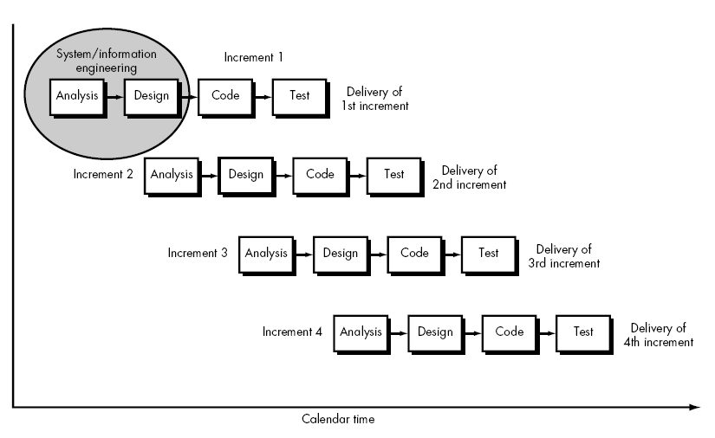

Figure 1: Incremental Model

Advantages of Incremental model:

* Generates working software quickly and early during the software life cycle.
* This model is more flexible – less costly to change scope and requirements.
* It is easier to test and debug during a smaller iteration.
* In this model customer can respond to each built.
* Lowers initial delivery cost.
* Easier to manage risk because risky pieces are identified and handled during iteration.

Disadvantages of Incremental model:

* Needs good planning and design.
* Needs a clear and complete definition of the whole system before it can be broken down and built incrementally.
* Total cost is higher than [waterfall](http://istqbexamcertification.com/what-is-waterfall-model-advantages-disadvantages-and-when-to-use-it/).

When to use the Incremental model:

* This model can be used if the requirements of the system are clearly defined & understood.
* Major requirements must be defined; however, some details can evolve with time.
* There is a need to get a product to the market early.
* Resources with needed skill set are not available

## 3.2 PROJECT DELIVERABLES

* Project team will be able to upload their project document and related demos. Furthermore, they will be able to answer the queries and resubmit the document as demanded.
* The reviewer will be able to review, give feedback and overall judge the project through web.

# PROJECT TASK AND SCHEDULE

## 4.1 TASK AND TIME SCHEDULE

The time schedule has been designed as per the requirements. This project is scheduled to be completed in about 2 and half months. Requirement analysis has been given more emphasis. System Design is to be done first. Testing and Debugging is to be done along with the development of the project. Finally, documentation is done throughout the project.



Figure 2: Gantt Chart

# REFERENCES

1. “lonely Planet” [Online]Available: http://www.lonelyplanet.com/

2. “Software Engineering-The Incremental model-Best online tutorial source code programming languages” [Online] Available: <http://www.1000sourcecodes.com/2012/05/software-engineering-incremental-model.html> [Accessed: 2016-08-08].

3. “What is Incremental model-advantages, disadvantages and when to use it” [Online] Available: <http://istqbexamcertification.com/what-is-incremental-model-advantages-disadvantages-and-when-to-use-it/> [Accessed: 2016-08-08].